Task:- Design low-fidelity wireframes for a mobile application.

Quick-Bite
Mobile App Wireframing — UX Design Case Study

Sk Altamash Ali
Intern ID:THX-JUL2126-688


July 2026

1. Project Overview
QuickBite is a mobile food-delivery app concept created to practice early-stage UX design planning: identifying user needs, mapping a user flow, and translating that into low-fidelity wireframes before any visual design is applied. This document covers the full design-thinking process — from research through to the final wireframes.

Problem Statement
Existing food delivery apps often hide delivery time and total cost until late in the ordering process, and require too many steps to complete checkout. This leads to cart abandonment and user frustration, especially for time-pressed users ordering on a break or after work.

2. User Research
Research method: short informal interviews with 5 regular food-delivery users (students and working professionals), asking about ordering frequency, pain points with existing apps, and what would make them order more often.

Key Questions Asked
- How often do you order food delivery, and from which apps?
- What frustrates you about existing delivery apps?
- What would make you order more often, or more comfortably?

Key Findings
- Users want to see estimated delivery time and total cost before browsing a restaurant's menu in depth.
- Users frequently abandon orders when checkout involves too many screens or steps.
- Users with repeat habits (students, professionals ordering the same meals) want a fast way to reorder past meals.
- Unclear delivery status after ordering ("where is my food?") is a recurring source of anxiety.

3. User Personas

Persona 1 — "Busy Student"
- Age 20, university student, orders food 3–4 times per week between classes
- Goals: fast ordering, low cost, quick reorder of favorite meals
- Frustration: too many taps required to complete checkout

Persona 2 — "Working Professional"
- Age 28, orders dinner after work, occasionally orders for family
- Goals: reliable delivery time estimates, easy saved payment methods, clear order tracking
- Frustration: unclear ETA and poor visibility into order status after placing it

4. User Flow
The core "happy path" flow below shows how a user moves from opening the app to receiving their order, and maps directly onto the seven wireframe screens in Section 5.
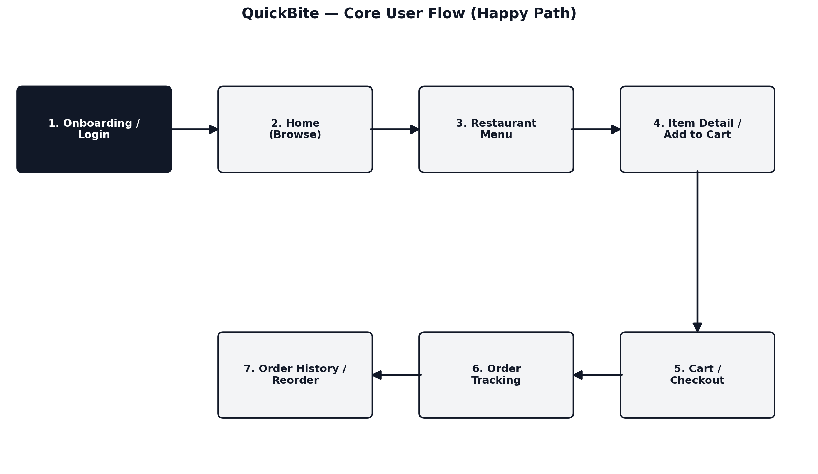
Flow: Onboarding/Login → Home (browse restaurants) → Restaurant Menu → Item Detail (add to cart) → Cart/Checkout → Order Tracking → Order History (reorder).

5. Low-Fidelity Wireframes
Wireframes were generated using Stitch (Google) in a strict grayscale, low-fidelity style — no color, no final imagery, placeholder blocks only — to keep review focused on layout, hierarchy, and flow rather than visual polish. Each screen ties back to a research finding or persona need, noted below.
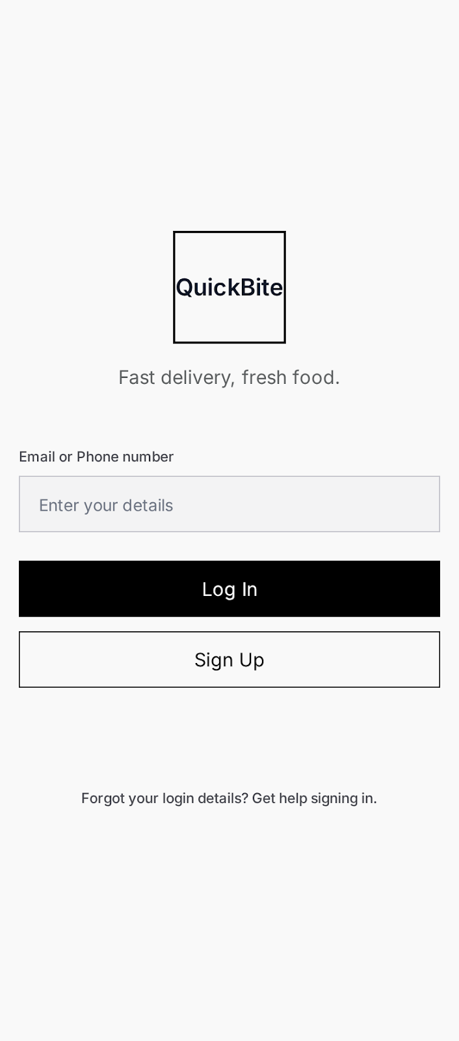  1. Onboarding / Login  Entry point for new and returning users. Simple email/phone login with clear Sign Up alternative — minimizes friction before browsing. | 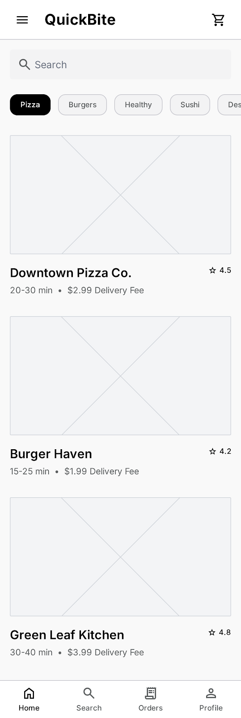  2. Home Screen  Search bar, category filter chips, and restaurant list with rating, delivery time, and fee shown up front — addresses the research finding that users want cost/time visible before committing.
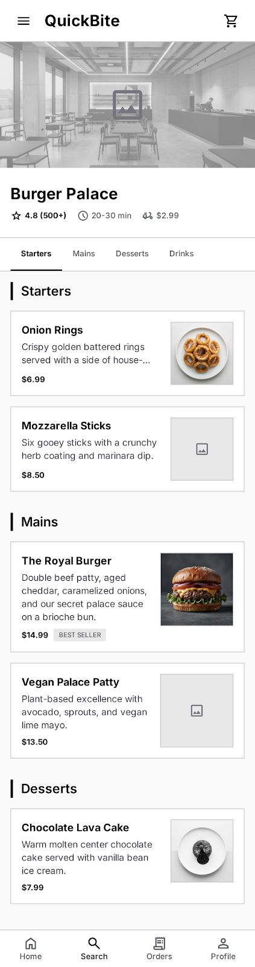  3. Restaurant Menu  Menu items grouped by category under the restaurant header, so users can scan quickly rather than scroll a flat list. | 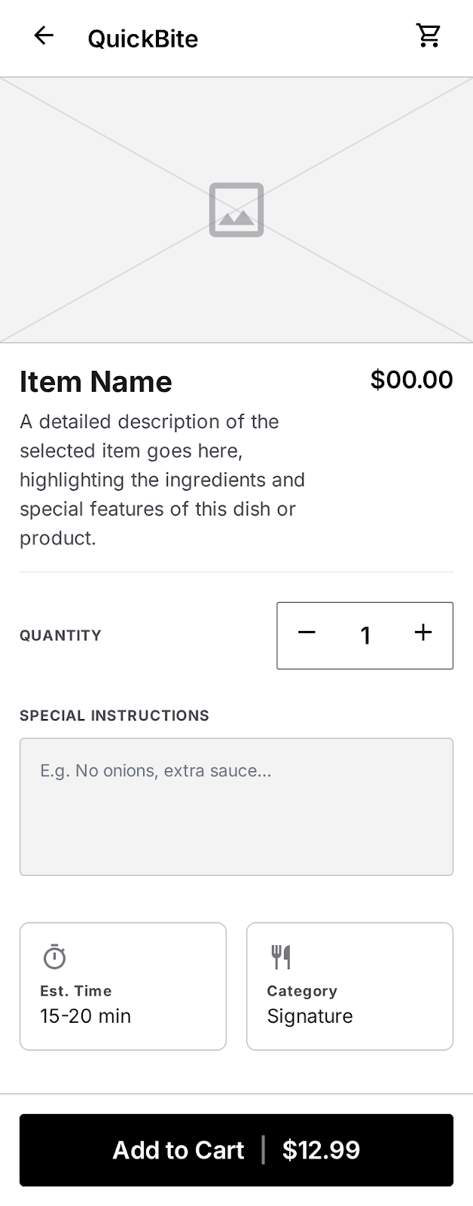  4. Item Detail  Quantity stepper and a persistent Add to Cart action keep the path to purchase short, addressing the 'too many taps' frustration from research.
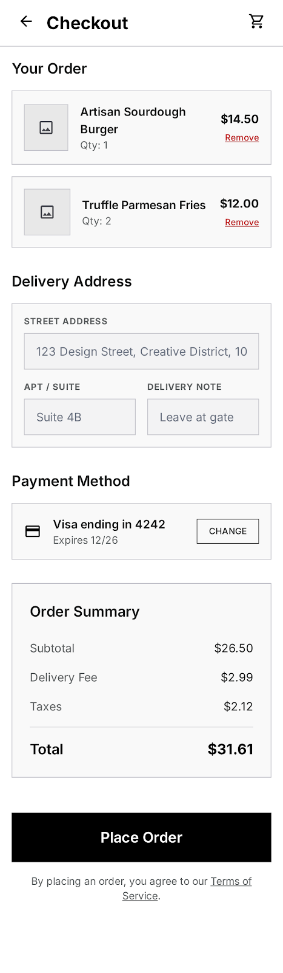  5. Cart / Checkout  Order summary, delivery address, payment method, and total are consolidated on one screen to reduce checkout steps. | 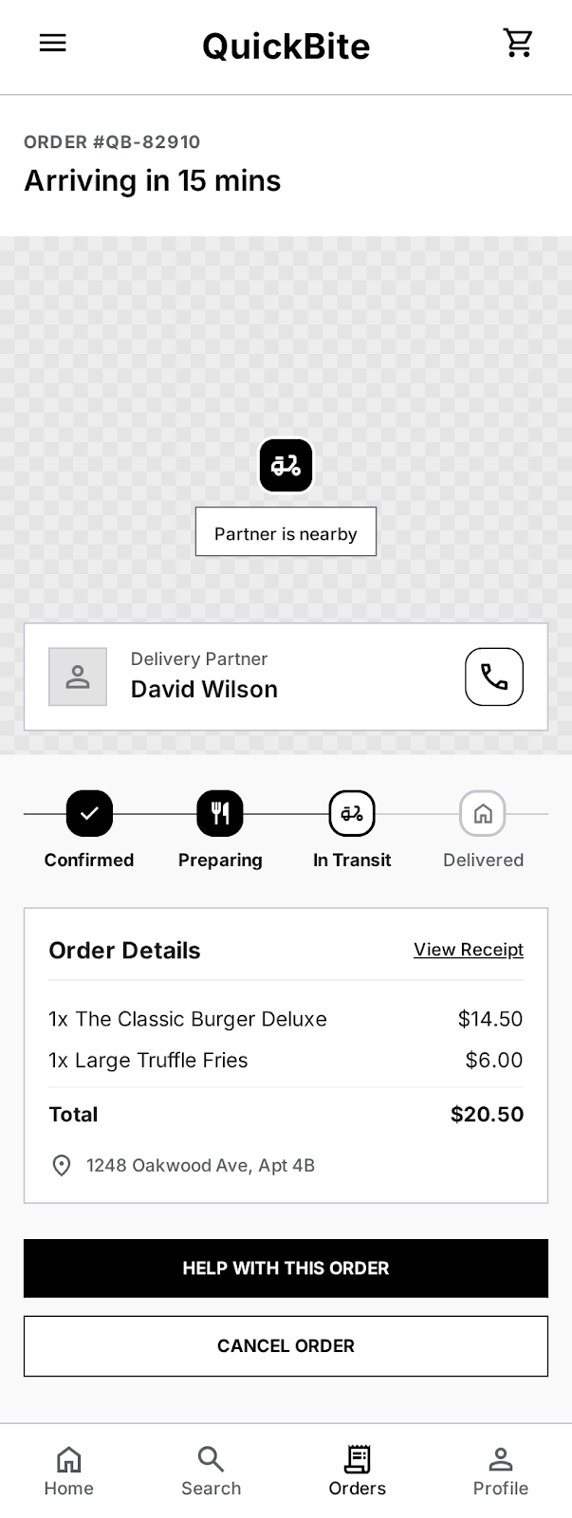  6. Order Tracking  A status stepper (Confirmed → Preparing → In Transit → Delivered) gives users the clear ETA visibility they said they lacked in other apps.
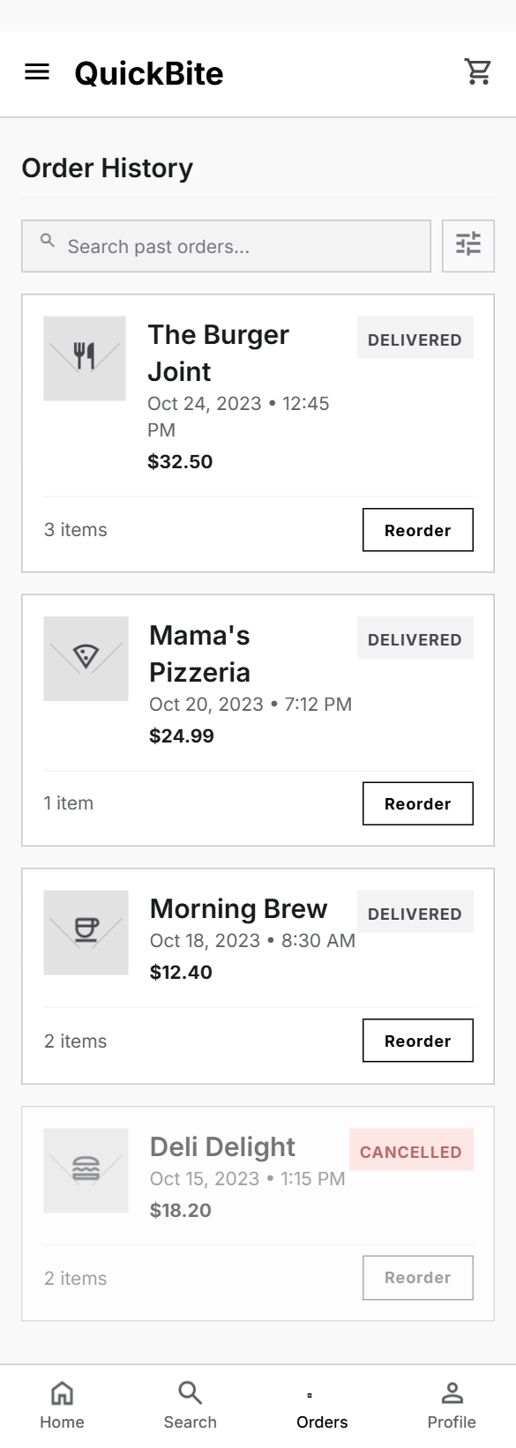
7. Order History
Past orders with a one-tap Reorder button directly serves the 'Busy Student' persona's need for fast repeat ordering.

6. Design Thinking Process

Empathize
Conducted informal interviews with regular food-delivery users to surface real frustrations (Section 2), and distilled them into two representative personas (Section 3) to keep design decisions grounded in actual user needs rather than assumptions.

Define
Problem statement: users abandon orders or feel anxious post-order because existing apps hide cost/time information early and provide poor order-status visibility. The design goal became: surface time/cost early, minimize checkout steps, and give clear real-time order status.

Ideate
Mapped the simplest possible path a user could take from opening the app to receiving food (Section 4), and identified exactly seven screens needed to support that path — deliberately avoiding extra screens that would add navigation overhead.

Prototype
Translated the flow into low-fidelity wireframes (Section 5). Grayscale and placeholder-only styling was used intentionally at this stage so that structural and flow feedback could be gathered without being distracted by color or branding decisions.

Reflect / Next Steps
- Usability test the checkout flow specifically, since it was the most-cited pain point in research.
- Validate whether users want delivery partner contact (phone icon) or prefer in-app chat only.
- Move to mid-fidelity design once flow and layout are validated, introducing the QuickBite visual identity (color, imagery, iconography).
- Consider a persona for occasional/first-time users who may need more onboarding guidance than the two personas above.

